Module 2: Baseline Assessment

Session 4: Livelihood Zoning

Handout 2 - Answers for Exercise on Livelihood Zones

Exercise 1
Compare the map of farming regions with the livelihood zone map below. Some of the differences are that the livelihood zone map takes into account:
- what people produce (what types of crops, what kinds of livestock);
- what they produce it for (as a food crop or a cash crop; whether it is grown for export);
- how they produce it (as small holders or as commercial farm workers, or as ranchers);
- where it is sold on to, if it is sold;
- the importance of other activities to the household economy (e.g. remittances, local work).

Livelihood Zone Map of Zimbabwe
(see overleaf for key)
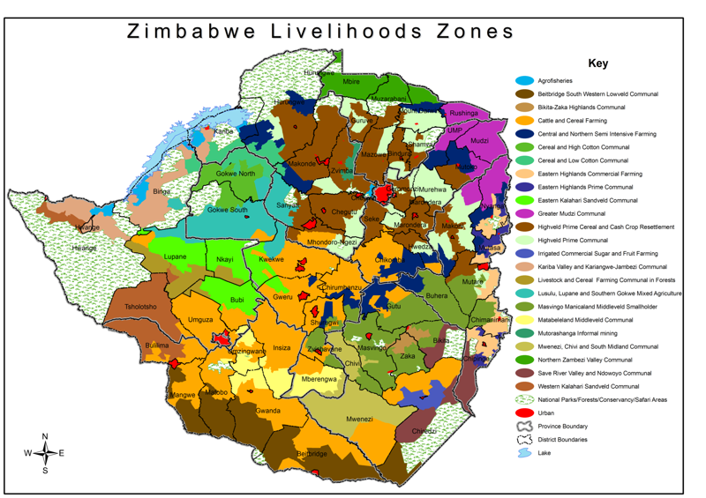

The National Livelihood Zone Map of Zimbabwe has 23 livelihood zones. This level of disagregation provides useful detail for planners working at regional and district level. More broadly, the livelihood zones fall into eight main types.

(i) The Eastern Highlands Commercial Zone: Export crops such as sugar cane, tea and coffee are grown. The lumber industry is the other main commercial activity in the region.

(ii) Mid/Highveld Communal Zones: Densely populated and intensively farmed, maize is popular but is one crop of many in a region that is well-suited to a range of food and cash crops. A second season of winter wheat provides an additional harvest during the year.

(iii) Mid/Highveld Resettlement Zones: Maize, winter wheat, tobacco and vegetables are grown. These were the farms that were targeted for re-distribution under the year 2000 fast track land reform programme.

(iv) Middleveld Communal Zones: Middleveld agriculture is dominated by maize and millet (the food crops), and groundnuts, sorghum and some cotton or paprika (the cash crops). Better-off farmers earn cash mainly from crop and livestock sales. The poor make ends meet mainly from daily wage work and gold panning.

(v) Mid/Lowveld Cotton Zones: Agriculture is a riskier proposition in the drier lowlands. Maize is the chief food crop; cotton the chief cash crop. The proportional importance of maize or cotton varies within the mid/lowveld “cotton” zones. Livestock sales, gold panning and daily wage work provide essential income for food purchases.

(vi) Lowveld Mixed Farming: Large-scale game and cattle ranches have given way to more mixed agriculture (cattle, game, and maize) as the new commercial and family farmers take possession of the resettled land in south-central Zimbabwe.

(vii) Lowveld Agro-Pastoral Zones: Only one zone in the south (Beitbridge lowveld) is most accurately described as agro-pastoral. The other lowveld economies (such as in the Kariba Valley) have a crop-livestock economic base that is increasingly propped up by remittances, local wage work and gold panning.

(viii) Irrigated Commercial Zones: Relatively small, these pockets of irrigated commercial production of fruit, sugar cane, and cotton provide a profitable addition to national exports.

Source: ZimVAC, Food & Nutrition Council, Save the Children
Exercise 2 - Suggested answers

- Although you are assessing an agricultural livelihood zone, you arrive in a selected village to find that there is a nearby lake and households are almost entirely dependent on fishing for their cash income. Should you carry on with the fieldwork for your baseline assessment in that village?

No. Explain politely to the village leaders that you are at present trying to build up an understanding of the agricultural way of life, and that you mistakenly thought that this village was an agricultural one. Take your leave as graciously as you can, making a note of the village and the fact that it is centred on fishing. Move on to the next village on your list. At the end of the day, report the fishing village to the team leader, who will investigate further and amend the livelihood zone map as appropriate.

- The four selected villages in the northern half of the livelihood zone are currently experiencing a drought, while those in the southern half are not. Should the livelihood zone be split in two for the baseline analysis?

The occurrence of a drought in one part of a zone does not warrant dividing it up into two separate livelihood zones. If the two areas share a similar pattern of livelihood and a similar vulnerability to drought, then they should not be split at this stage of the analysis. Separate analyses of outcome will be required for the north and for the south, but this is not an analysis that requires the division of the zone into two at the stage of compiling the basic livelihood zone map. The drought is a hazard – not part of the baseline, but the outcome analysis.

- The western half of the livelihood zone has good access to clean water and health care because of an NGO programme in the area, while villages in the eastern half of the livelihood zone have very poor access. Should the livelihood zone be split in two for the baseline analysis?

It is not usual to divide a livelihood zone into two because one part has better health or education services than another; differences in service provision (number of clinics, schools, etc) do not necessarily reflect different livelihood patterns. But why not, when a livelihood may be defined as the sum of ways in which households obtain the things necessary for life, including health care and education?

A livelihood zone map is developed in order to assist with emergency and development decision-making. We may be trying to answer questions such as; how will people in different areas be affected by a hazard (e.g. drought), and what might be their need for food and/or economic assistance? Or how best can we design development interventions that will support rather than undermine existing livelihood strategies? These are questions that are best answered through an understanding of the economic operations of individual households, not in relation to existing levels of local service provision.

This is not to say that mapping levels of service provision would not be a useful activity in its own right. However, rather than incorporating this into the definition of individual livelihood zones, the most useful procedure might be to overlay maps of service provision onto the final livelihood zone map. This would help to identify which parts of which zones are poorly served, perhaps highlighting priority areas for intervention in the health and education sectors.

